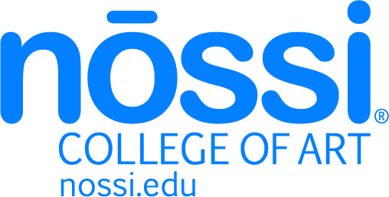

DATE: 15 April 2020 FOR IMMEDIATE RELEASE
CONTACT: Libby Funke Luff
PHONE: 615.514.2787
EMAIL: lfunke@nossi.edu

Nossi College of Art Launches AI Experience Using Facebook’s Messenger APP During COVID-19

NASHVILLE, TN - Utilizing technology to communicate with Gen Z and younger audiences is extremely important to a successful college admissions process. When looking for an impactful way to speak with their audience, Nossi College of Art partnered with an interactive design graduate and Cloud Cycle, a digital marketing agency, to launch Phase 1 of Nossi College's Facebook Messenger ChatBot.

"As a former student, I was able to help highlight the best parts of Nossi College and the things future students would be interested in," said Shelby Carr, a Fall 2017 Interactive Design graduate. "I never thought after graduating that I would get to work on projects with them in the future."

Designed to chat with students pursuing a creative career like Carr's, Nossi College's Chat Bot gives users control over the conversation. Uncover degree programs, course highlights, student work, career services, and campus culture. Nossi's Chat Bot adapts information from the College's website and delivers it in conversational pieces while using pictures and GIFs to keep users engaged.

"This generation currently enrolling in college is unique; texting, social media, and chatting have always been a part of their lives, "said Britney Binkley, Owner of Cloud Cycle LLC. "It's more natural to them and often times their preferred way to communicate."

Nossi College considered Carr's help a vital resource in not only designing the app but also in presenting the College to ChatBot users.

"Having an alumnus work at Cloud Cycle brought a unique perspective to this project," said Libby Funke Luff, Nossi's Marketing and Student Activities Director. "Shelby allowed us to highlight the advantages she considered valuable to her college education and experiences."

Nossi College is using one of the top Messenger applications to best communicate with their audience. The interaction will reveal ways Nossi can continue to share relevant content with users.

"The Nossi Messenger Bot is now a living thing that can grow and adapt to meet the needs of its users,' said Binkley. "It's exciting, and we are thrilled to be a part of its development."

ABOUT
Founded in Nashville and established in 1973, Nossi College of Art is Tennessee's only professional art college. Teaching about technology's impact on the arts and emphasizing a variety of career paths, Nossi College continues to evolve and stay relevant for graduates. Their professional development approach helps artists find success in the commercial business world. Nossi College offers an associate and bachelor's degrees in Commercial Photography, Web & Interactive Design, Video & Film, Graphic Design Media, and Commercial Illustration.

Related links: nossi.edu

